**NEWS APPLICATION**

**By**

**Nandini sachan– 19BEC1216**

***A project report***

in partial fulfilment of the requirements for the course of

**JAVA SPRING BOOT**

 

**Vandalur – Kelambakkam Road HMT nagar – Nacharam**

**Chennai – 600127 Main Road**

**Hyderabad - 500076**

**December 2021**

**INDEX**

# INTRODUCTION

* 1. Overview
  2. Purpose

# THEORITICAL ANALYSIS

* 1. Block diagram
  2. Hardware / Software designing

# FLOWCHART

# RESULT

# ADVANTAGES & DISADVANTAGES

# APPLICATIONS

# CONCLUSION

# FUTURE SCOPE

# APPENDIX

1. **Source Code**
2. **Application**
3. **INTRODUCTION**
   1. **OVERVIEW**

News search application provides trending news, all news and news according to user search. The News Search API lets you send a search query to Bing and get back a list of news that are relevant to the search query. Users can get all kinds of news according to their need easily on a single platform, whenever they want and wherever they want. This app makes it easier for them to access news at their fingertips. Users don’t have to visit different websites or flip through the pages of their daily newspaper to go through their favourite topic. They can easily view the relevant news through this application.

* 1. **PURPOSE**

The main objective of the project is to provide people a handy android application through which people can access all types of news and information. Through this any user can gain knowledge of the world and its surrounding with just one click ahead. User does not have to visit multiple websites for different related information. All information is going to be in one place Many people generally get the redundancy in the information. Even spread fake news, Sometimes, people which circulates and spread more like a disease of false information in WhatsApp and other social media. Various myths are also likely to spread as soon as possible which gives more harm than good to the people. The purpose is to develop an application, which will eliminate the problems faced in the current scenario. This application will provide all the information and news that are in trend at one place. So, it will save time and efforts of the users by making it more efficient. Using, this application will terminate the possibility of information redundancy.

1. **THEORITICAL ANALYSIS**
   1. **BLOCK DAIGRAM**

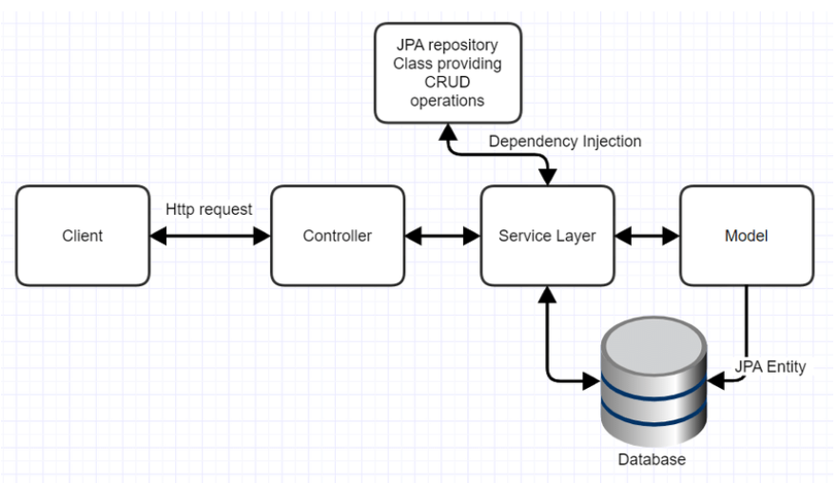

**Fig 1: spring boot application block diagram – news app**

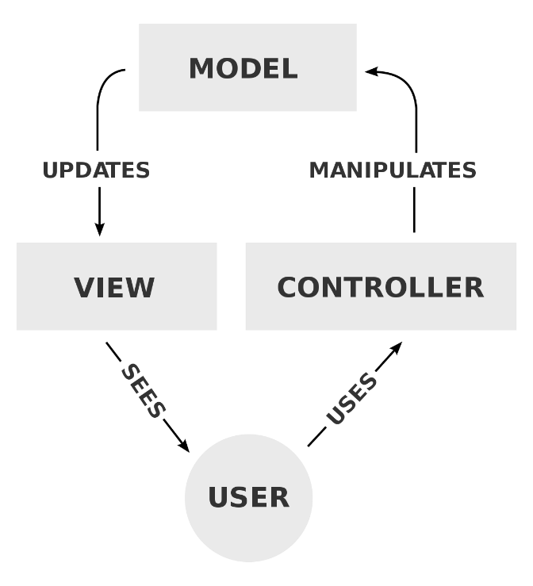

**Fig 2: Model View Controller**

* 1. **SOFTWARE DESIGNING**

Operating system: Windows, Linux or IOS

Coding Language: Java, HTML, CSS

IDE: SpringToolSuite4

Other requirements:

Rapid API – for news search,

MySQL – for database,

Heroku – for deployment

1. **FLOW CHART**

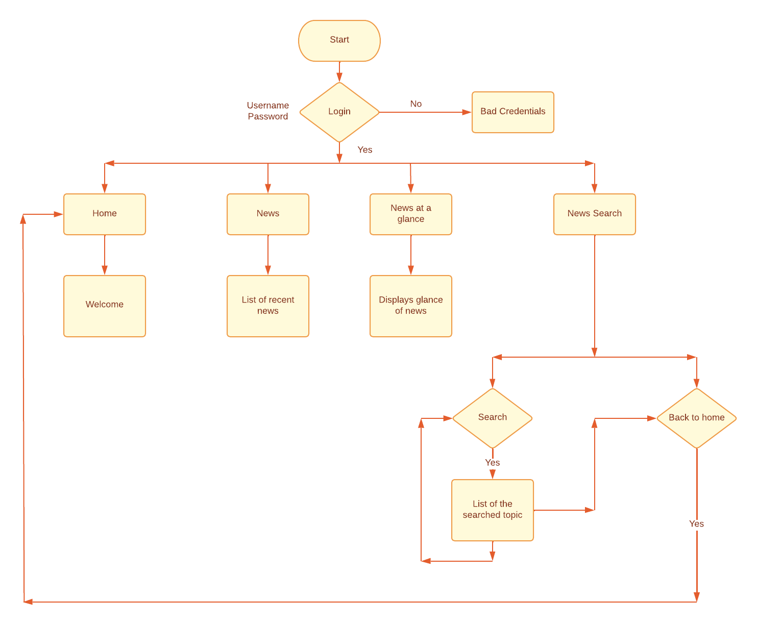

**Fig 3: Control flow of News App**

1. **RESULT**

This section contains the output of news application.

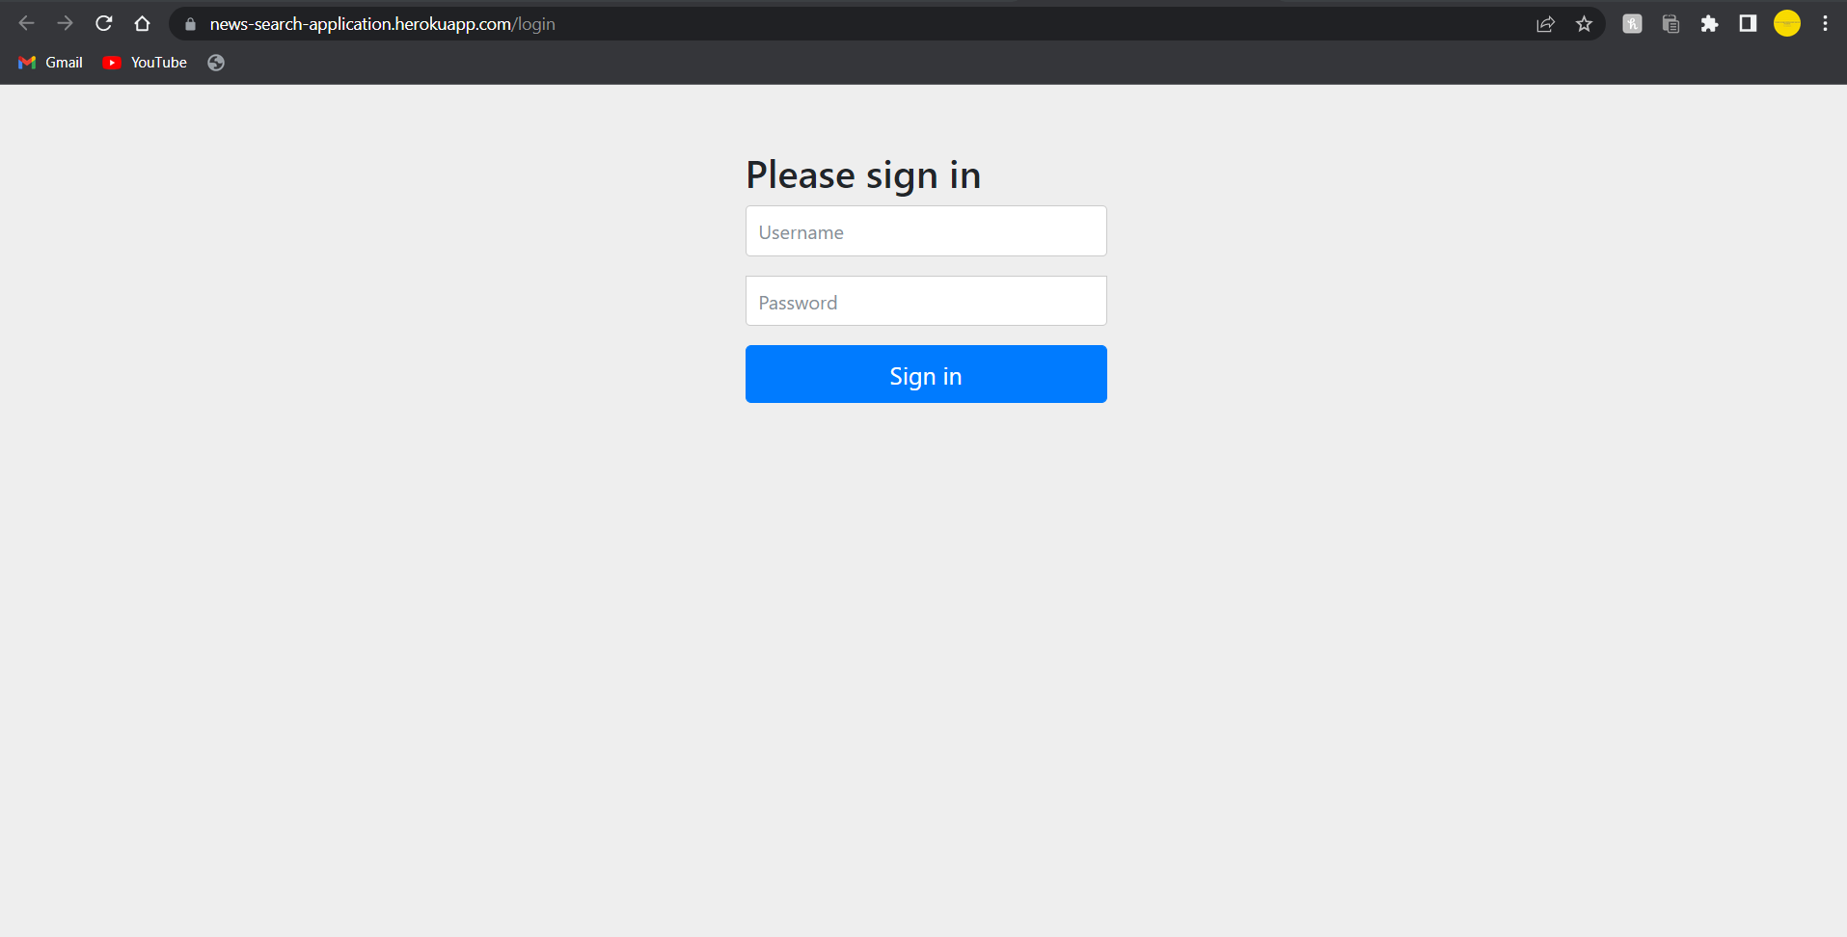

**Fig 4: Sign in page**

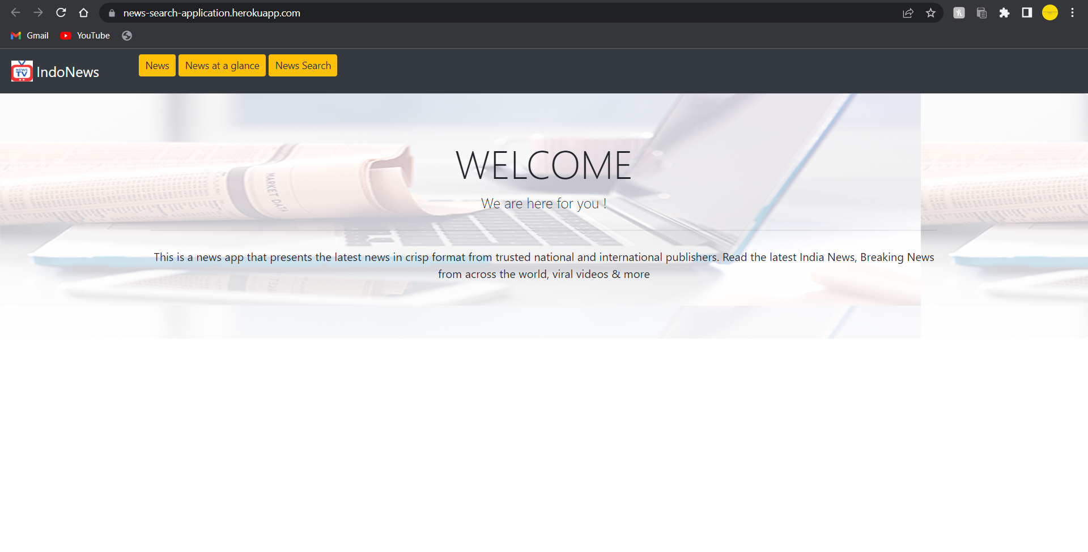

**Fig 5: Welcome page**

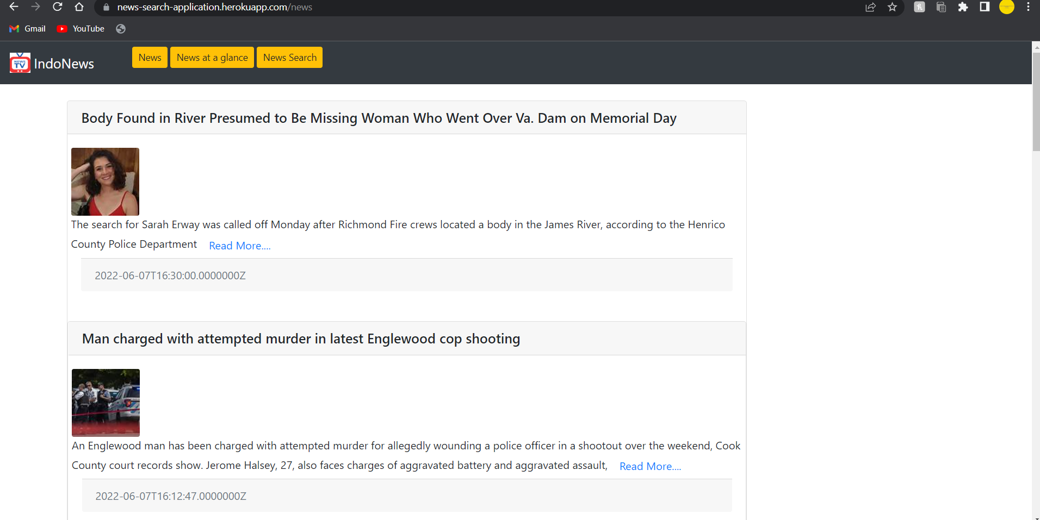

**Fig 6: News page**

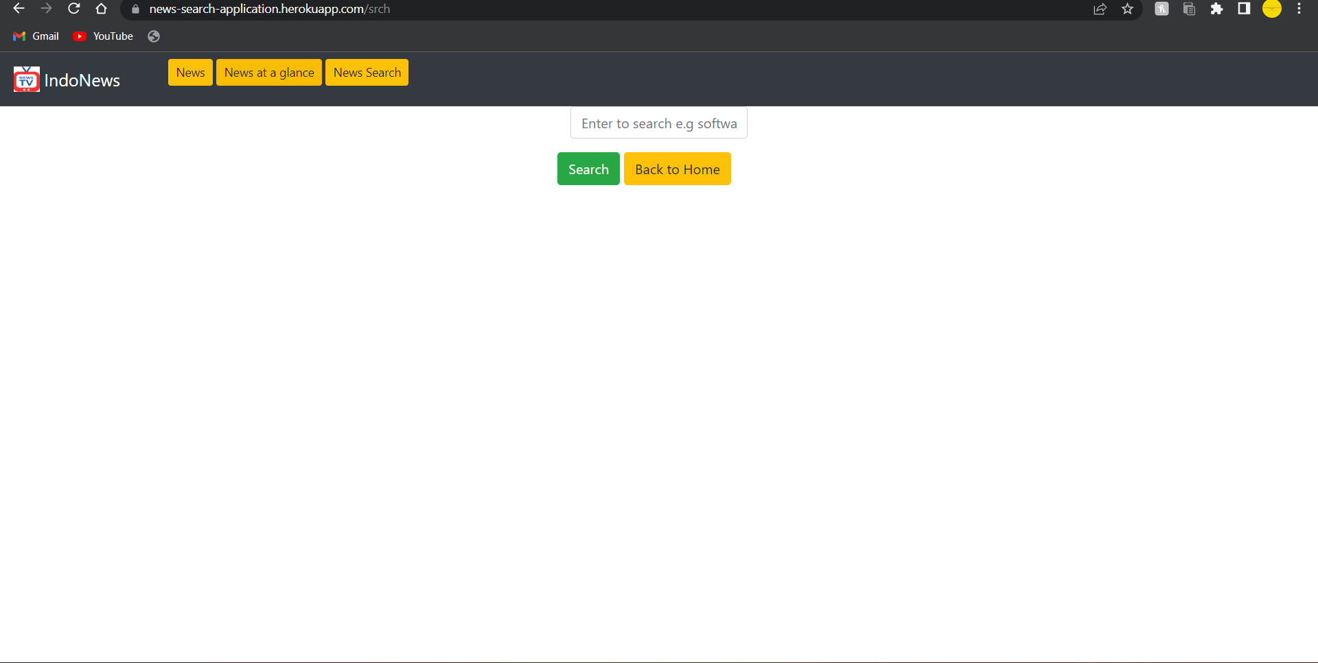

**Fig 7: Search page**

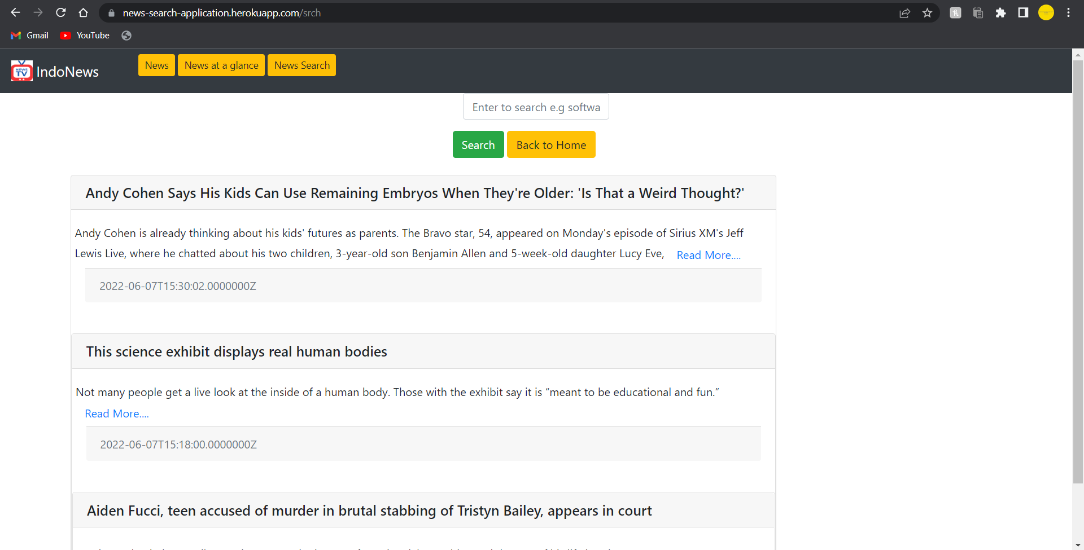

**Fig 8: Search results**

1. **ADVANTAGES AND DISADVANTAGES**

**ADVANTAGES**

Since a majority of readers have advanced to technology, there are reasons why every major to small media agency have digitized themselves. Becoming a part of our personal lives, these major benefits of digital news media can be seen in the following ways.

### 1. Information Goes Paperless

Every piece of update you receive is through electronic media hence saving the environment. A tree flourishes for every paper saved.

### 2. Updates on the Go

Digital News Media allows you to select the type of news you are into, and these updates are just a tap away. News Apps provide you relevant content as per your preference that you can access with ease anywhere and at any time of the day.

### 3. Digital Media Keeps you Socially Active

More and more users receive updates through social platforms like Facebook and Twitter. As celebrities and leading politicians use such platforms to deliver their concerns, many people are influenced by what appears on their profiles.

### 4. Globalization

Thanks to the internet that enables News Media to bring coverage to the global audience. News channels are not just restricted to a particular now, as you can access content from anywhere. Digital News Media removes regional restrictions by presenting the regional events to the world expanding their viewership.

**DISADVANTAGES**

With the ease of access and instant updates come some negative effects of Digital News Media.

### 1. Fabricated Content/Hoax

A sudden wave of fake news hits a wider part of global population when circulated through digital platforms like Facebook, Twitter, and WhatsApp. Concern about misinformation and disinformation remains high despite efforts by leading online journalism platforms to build public confidence.

### 2. Negative Content

Accessing the internet is more convenient to everyone. It’s easier for unscrupulous elements to spread negativity about a particular individual or group. The spread of unfounded rumors has led to a spate of uncivilized acts in countries like India. Several countries have set up ‘tip lines’, appealing to the public to flag illegal or dangerous content.

The spread of negative or hateful news often happens via groups that are set up specifically to discuss sensitive issues.

### 3. News Overload

Apart from the leading international news channels, internet has helped many less popular news channels to evolve at a rapid rate. There is more news around the web circulating through different platforms. This is rather more confusing than to figure out what’s going on really.

1. **APPLICATIONS**

This news app collects articles from a large pool of sources, so instead of getting stories just from the New York Times or a local news station, you'll get a good mix. This app can be used or developed further by a news agency that want to improve their customer experience and cultivate customer loyalty. This application can also be used by individuals who want to start their journalism journey or start their own news channel. Since applications require only an internet connection, they can be accessed by anyone anywhere. It helps in increasing number of users. News channels can use such apps to enhance user loyalty. These apps come in handy and play a vital role in spreading important information effectively so that more and more users can be well informed. This app can be very useful for students who spend most of their time studying. Students can easily access news without a television or cable connection. This app can be useful for spreading news in disaster affected areas as it is hard for media to reach such places and cable or newspaper services are cut off. People affected can still stay connected to the world and can also share their own reports. These are some of the most important applications of the news app.

1. **CONCLUSION**

This is a fast - evolving world with modernization taking a toll on the world, people nowadays prefer to spend time more on their mobile rather than read a newspaper or watch television. News app is an application which makes news reading much interesting and easier. The easily usable UI makes this application very user friendly and most of all save time.

1. **FUTURE SCOPE**

This version of the app is in the seeding stage and there is a lot of room for future enhancements. Features that can be added for later versions are as follows: Videos of latest news, watch/read this later, notification for updates on a particular article, user interface design for website and mobile phone for both iOS and Android, development of all functional requirements for the web and mobile application, people with the same interest can interact with each other. However, they can even share more information on the topic.

1. **APPENDIX**
2. **Source Code**

[**https://github.com/12nandini/news-search-application**](https://github.com/12nandini/news-search-application)

1. **Application**

[**https://news-search-application.herokuapp.com/**](https://news-search-application.herokuapp.com/)